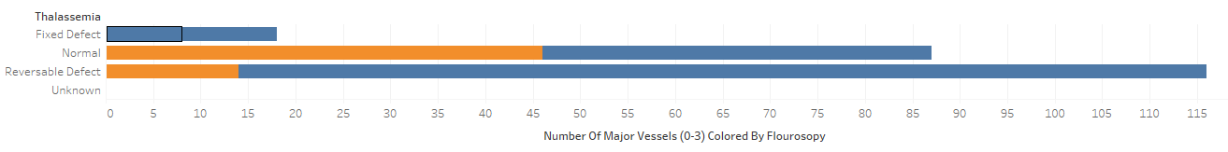

Blue – Disease, Orange – No Disease

We discovered that the number one large marker was the number of major vessels colored by flourosopy that contributed to major disease. Much more evident was the amount of major vessels that would be colored after exercise angina was introduced.

This led to a design change as the circular threshold wasn’t nearly as accurate when attempting to portray the multitude of data. The area per bubbles in order to meet a threshold was quite difficult as a difficult algorithm would have to be created in order to determine what that threshold would have to be. Then the weight of each data dimension would then we have to be determined not only in accordance with the target, but correlating with the other data dimensions as well.

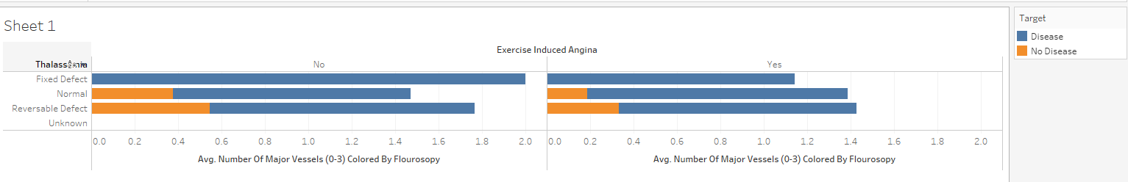

This design change was then determined as to whether the average of the fluoroscopy would provide a better reference point per patient as opposed to the sum. Here we can see that regardless of exercise induced angina, if even one major vessel is coloured the chance of heart disease is 100%.